Sunday 7th May 2023 - Coronation
Duck Racing - Prizes & Donations

Auction
Winner - £40 voucher - Martins Arms
All purchasers of ducks received wine and Stilton
Colston Basset & District Dairy and Colston Bassett Ball

Ducklings’ Derby 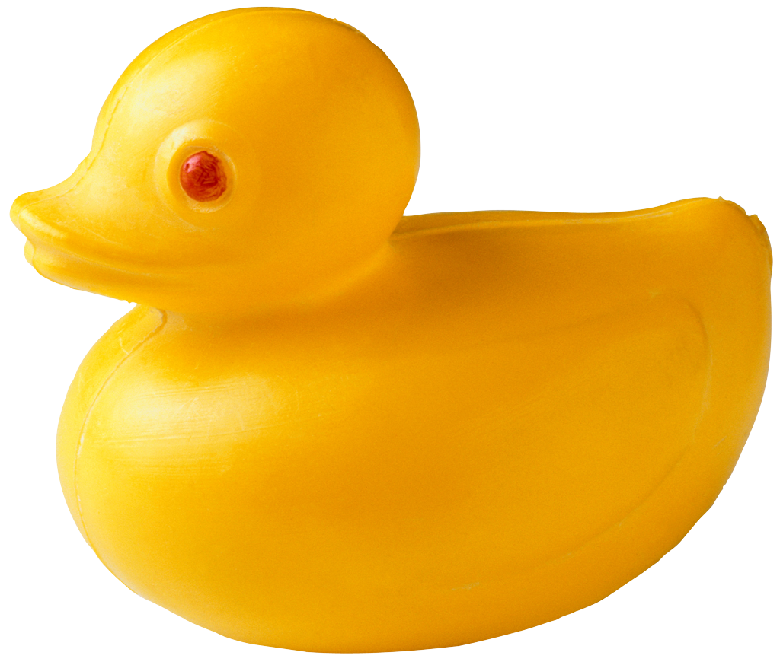

Winner - £50, Champagne & Challenge Cup
Colston Bassett & District Dairy, Belvoir Boarding Kennels & John Wallwin
2nd Blade Fan
Paul Landa
3rd £40 John Lewis Voucher
Colston Bassett Parish Council
4th Luxury Hamper
Celia Wallwin
5th £35 M&S Voucher
Village Ventures
6th £25 Cod’s Scallops Voucher
John Molnar
7th £25 M&S Voucher
Colston Bassett History Group
8th Vintage Port
Wendy Reed and Ian Hooper
9th Digital air compressor
Kay Landa
10th BBQ Tools
Paul Landa

Last Duckling Home - £25 & mini-Challenge Cup!
Pen Hill Framing, Colston Bassett

