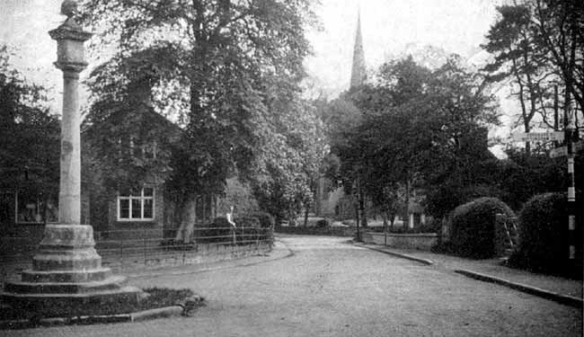
Colston Bassett Parish Council

Colston Bassett Parish Council Meeting January 17 2022
Given the ongoing risk of Covid-infection and with consideration of any urgent business the Parish Council meeting planned for Monday January 17th has been CANCELLED
Items that are outstanding for discussion by Parish Councillors include decisions on the 2022/3 Mowing Contract and on the Co-Option of Councillors, as well as discussions around any Platinum Jubilee local celebrations. These items will be reconciled by Parish Councillors as appropriate via email, telephone & Zoom as required and ratified at their next meeting.
The next Parish Council meeting, which will include the 2022 ANNUAL PARISH MEETING, will be held on 21 March 2022 from 7pm in the Colston Bassett Village Hall

Nige Mayglothling
Clerk to Colston Bassett Parish Council
January 2022

